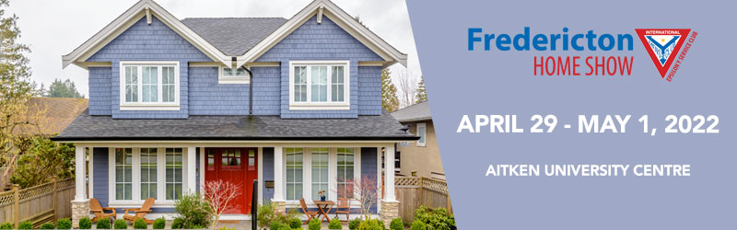
Central New Brunswick’s Home
Improvement Event.

The Fredericton Home Show is returning at a new location, Aitken University Centre, April 29 - May 1, 2022, kicking off construction and renovation season once again. The show offers a unique opportunity to interact and engage with those who are looking to make informed decisions about their building and renovation projects.

Looking for impactful, creative ways to build your brand? Sponsorship is a fantastic way to position your company name in front of the show’s annual visitors. The show has consistently attracted over 10,000 visitors. Read on for ways to reach them at the show!
ACT NOW!
Many of the opportunities are limited in number, so don’t delay! All sponsorship opportunities are available on a first come, first served basis.

CUSTOM PACKAGES AVAILABLE
If you don’t see what you are looking for or would like to discuss a unique package tailored to your company’s specific needs, please don’t hesitate to reach out to your show manager:

Brian McKiel, Show Manager
bmckiel@mpltd.ca
1-888-454-7469 (SHOW) • 506-649-0024

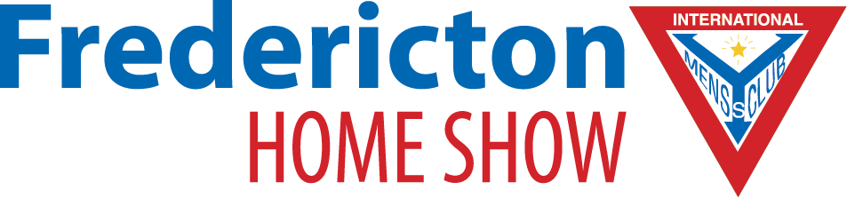
SPONSORSHIP OPPORTUNITIES

IMPORTANT NOTES ON SPONSORSHIP:

- Many of the available sponsorship opportunities include the provision of merchandise from the sponsor in addition to the price (i.e., bags). Should you prefer, a new price can be offered that includes the product in question.

LOBBY SPONSOR | $2,500
Sponsor the main entrance area and set the tone for the event. This sponsorship includes:
- Signage at main lobby
- Exclusive marketing collateral distribution rights at main entrance
- Web banner top ad on event homepage
- 100 ‘admit one’ event passes

FLOOR SIGNAGE SPONSOR (2 available) | $1,500
This sponsorship includes:
- Decals branded with your company logo will be placed in high traffic areas, leading from the show entrance directly to your booth. This will extend your reach outside the exhibit area. This package includes 20 vinyl 2’ x 1’ arrows imprinted with your graphic in full colour.

DIGITAL MEDIA SPONSOR | $750
This sponsorship includes:
- A leaderboard ad in our e-newsletter (minimum 2 occasions)
- 20 ‘admit one’ event passes
- Logo inclusion in television ads as an event sponsor!

SIGN ON AS A SPONSOR TODAY!

Have a unique partnership idea? Let us know and we can help
you design a custom package that’s just right for your company.

Brian McKiel, Show Manager – bmckiel@mpltd.ca
PO Box 565, Saint John, New Brunswick E2L 3Z8
Phone: 1-888-454-7469
www.masterpromotions.ca
G.S.T. Number 10355 7344RT

SPONSORSHIP CONTRACT

All correspondence regarding sponsorship will be directed to the individual and address noted below.
Company Name
Contact Name
Mailing Address
Phone
Fax
Email
SPONSORSHIP OPPORTUNITIES
Please indicate the opportunity you would like to sponsor:
 | SPONSORSHIP OPPORTUNITY |  | PRICE (plus applicable taxes)
 | Lobby Sponsor |  | $2,500
 | Floor Signage Sponsor |  | $1,500
 | Digital Media Sponsor |  | $750

Payment due by February 9, 2022

- Cheque enclosed (Please make cheques payable to Master Promotions Ltd.)
I have read and agree to the terms outlined in the 2022 Fredericton Home Show sponsorship package and contract, and agree to sponsor this event
this ___ day of ____________________ , 20__.

Signature per Master Promotions Ltd. |  | Sponsorship Applicant’s Signature

